Q-SafeSync
Physics-Informed Neuroplasticity for Safe Quantum Continual Learning
Complete Project Blueprint: Problem Statement, Literature, Architecture, and Pipeline
B.Tech, Artificial Intelligence and Data Science
Amrita Vishwa Vidyapeetham, Coimbatore
July 2026

1. Problem Statement
Artificial intelligence operating in dynamic, real-world environments requires the capacity for lifelong, continual learning. Standard deep learning architectures suffer from a fundamental limitation known as loss of plasticity, in which networks progressively lose their ability to adapt to new data over long task sequences, due to unbounded parameter growth and network saturation.
Recent research (our base paper, Chen & Zhang, 2026) has shown that Quantum Neural Networks (QNNs) provide a structural solution to this: because quantum operations are constrained by unitary evolution, weight growth is naturally bounded, and learning plasticity is preserved indefinitely. Separately, researchers have adapted classical stability techniques — particularly Quantum Elastic Weight Consolidation (EWC) — to stop these highly plastic quantum models from catastrophically forgetting old tasks, by statistically identifying and protecting important parameters.
The gap this project addresses:
Existing quantum stability mechanisms protect parameters based purely on generic statistical importance (reward-based Fisher Information). They cannot distinguish between a parameter that encodes a minor behavioral preference and one that encodes a critical physical safety boundary. In continuous control settings (autonomous navigation, robotics), this is a real failure mode: a quantum agent adapting to a new environment can overwrite the exact parameters responsible for basic safety (e.g., collision avoidance) in order to chase short-term reward on the new task.
This is a correct and well-grounded problem statement. It does not overstate what has been proven — it accurately separates the two verified findings (quantum plasticity is solved structurally; quantum stability is not) and identifies a real, specific limitation in how existing stability mechanisms measure importance. One precision to keep in mind: this is demonstrated across the tested benchmarks in the cited literature, not proven as a universal law for every possible quantum architecture.

2. Literature Review Summary
All core citations below were independently checked against their original sources. The literature underpinning this project is accurate and well-chosen.
Paper | Verified Core Contribution | Relevance to Q-SafeSync
Chen & Zhang (2026), PRX Quantum — Base Paper | Proves QNNs intrinsically preserve plasticity via unitary constraints, across thousands of sequential tasks. | Our foundation architecture (Part A) — kept unchanged.
Jiang et al. (2022), Chin. Phys. Lett. | First to show quantum classifiers suffer catastrophic forgetting; fixed it with quantum EWC. | Confirms stability is not automatic — motivates our S-FIM mechanism.
Zhang et al. (2024–25), npj Quantum Info | Real 18-qubit hardware; quantum EWC via parameter-shift FIM; 92.3% average accuracy across 3 tasks (verified directly from the paper). | Our hardware precedent and stability baseline to compare against.
CQural / Jain (2023) | Hybrid CNN+quantum architecture with GradCAM explainability, limited to classical pixel-space. | Motivates our XAI dashboard — but ours explains the quantum circuit itself, not just pixels.
Aslam et al. (2025), Wiley Survey | Maps biological brain mechanisms to classical continual-learning algorithms. | Confirms bio/physics-inspired stability is a legitimate, recognized direction.
Garg et al. (2026), FOPNG | Classical Fisher-orthogonal projected natural gradient descent — more rigorous than EWC, but Euclidean-only. | A future upgrade path: extending our S-FIM into a full information-geometric projection.
Wierichs et al. (2020), Quantum | Quantum Natural Gradient outperforms ADAM/BFGS on VQE landscapes, especially under overparameterization. | Justifies using natural-gradient-style optimization in our own training loop.
Dohare et al. (2024), Nature | Classical networks lose plasticity; fixed only via intrusive engineering hacks (forced unit reinitialization). | Context: shows why the quantum route is structurally cleaner than classical fixes.

One correction carried over from the source material: a secondary news article reported a “95.8% vs. 81.3%” classical-vs-quantum comparison for the Zhang et al. hardware paper. This specific comparison could not be verified in the paper's own abstract, which states only that the quantum classifier outperforms a comparable classical network, with a verified average accuracy of 92.3% across all three tasks. Use 92.3% as the citable figure; treat 95.8%/81.3% as unverified unless confirmed directly from the paper's full results section.

3. Our Approach, in Two Parts
The cleanest way to understand this project is as two layers: Part A is the plasticity foundation we borrow, unchanged. Part B is the stability mechanism we are contributing, built on top of it.

3.1 Part A — The Plasticity Foundation (Borrowed, Unchanged)
This part is not our contribution — it is Chen & Zhang's proven result, which we adopt as-is because it already solves half of the stability-plasticity dilemma for free.
- A deep Hardware-Efficient Ansatz: multiple layers of Rx, Ry, Rz rotation gates on each qubit, interleaved with a ring of CNOT entangling gates.
- Because every trainable parameter here is a bounded rotation angle (not an unbounded classical weight), the model's learning capacity cannot collapse, no matter how many tasks it sees in sequence.
- A necessary fix versus the original blueprint: the classical pre-processing step (compressing raw environment state into qubit-ready form) must be a fixed, non-trainable transformation — not a trainable deep neural network. A trainable classical network in front of the quantum circuit would reintroduce unbounded weights, undermining the exact plasticity guarantee this part exists to provide. This fix is discussed further in Section 5.
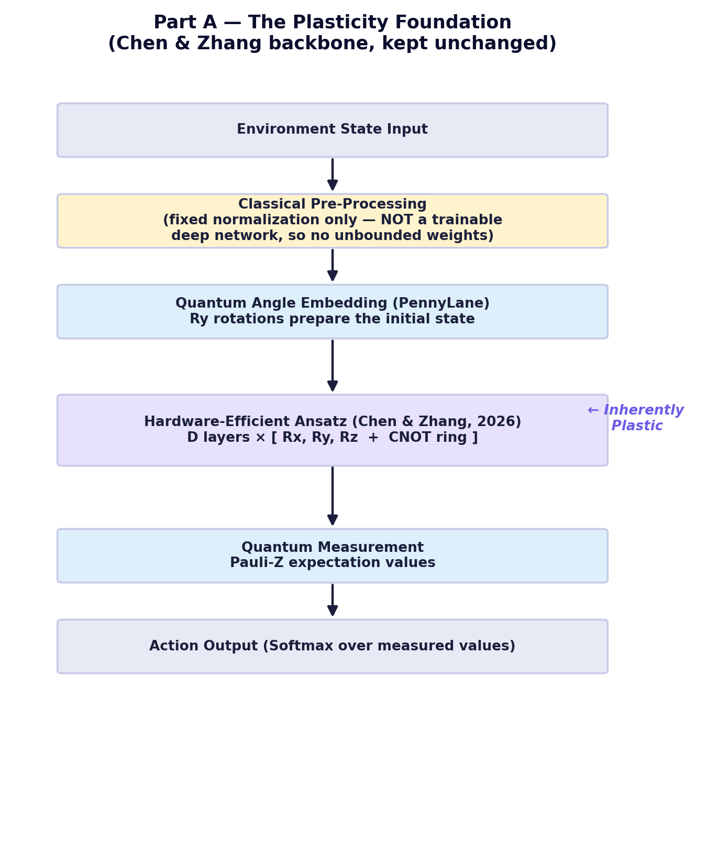

3.2 Part B — The Safety-Weighted Stability Lock (Our Novel Contribution)
This is the part we are actually contributing. Instead of protecting parameters based on generic statistical importance (as EWC does), we protect them based on physical safety relevance.
- Every time the agent acts, we compute a physical safety cost C(s, a) from the environment — for example, how close the agent came to a collision boundary.
- We use the quantum parameter-shift rule to compute a Safety-Weighted Fisher Information Matrix (S-FIM): instead of asking “which gates mattered for getting a high reward,” we ask “which gates mattered for staying safe.”
- Gates with high S-FIM values (safety-critical) get a heavily reduced learning rate — they are effectively locked. Gates with low S-FIM values stay fully plastic and adapt normally to new tasks.
- No raw quantum state or past experience needs to be stored — only classical S-FIM scores — keeping this compatible with the No-Cloning Theorem.
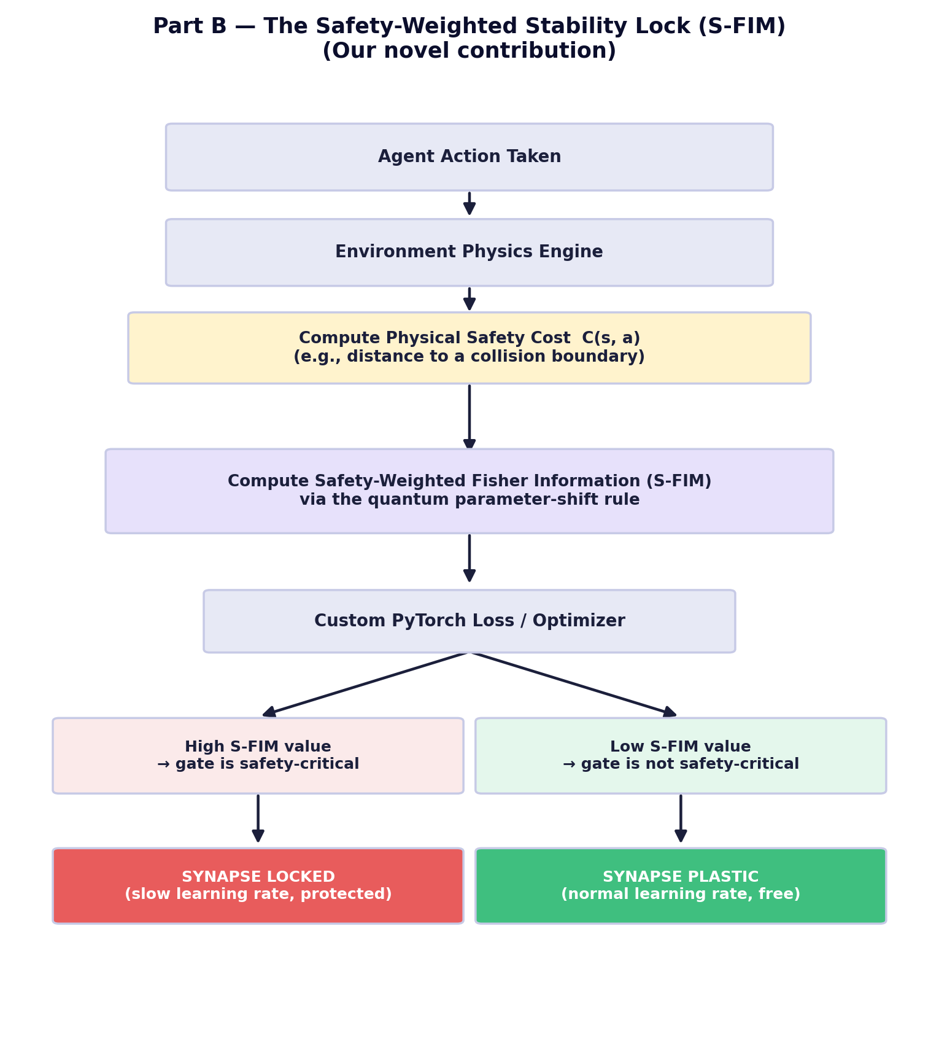
Why this is a genuine improvement over existing stability methods (Papers 1 and 2): those methods use reward-based importance, which cannot tell the difference between “this gate helped score bonus points” and “this gate prevented a collision.” S-FIM makes that distinction explicit and central, which is exactly the kind of domain-specific refinement a generic statistical method cannot provide.

4. The Complete Q-SafeSync Architecture
This diagram combines Part A and Part B into the full working system, including the explainability layer.
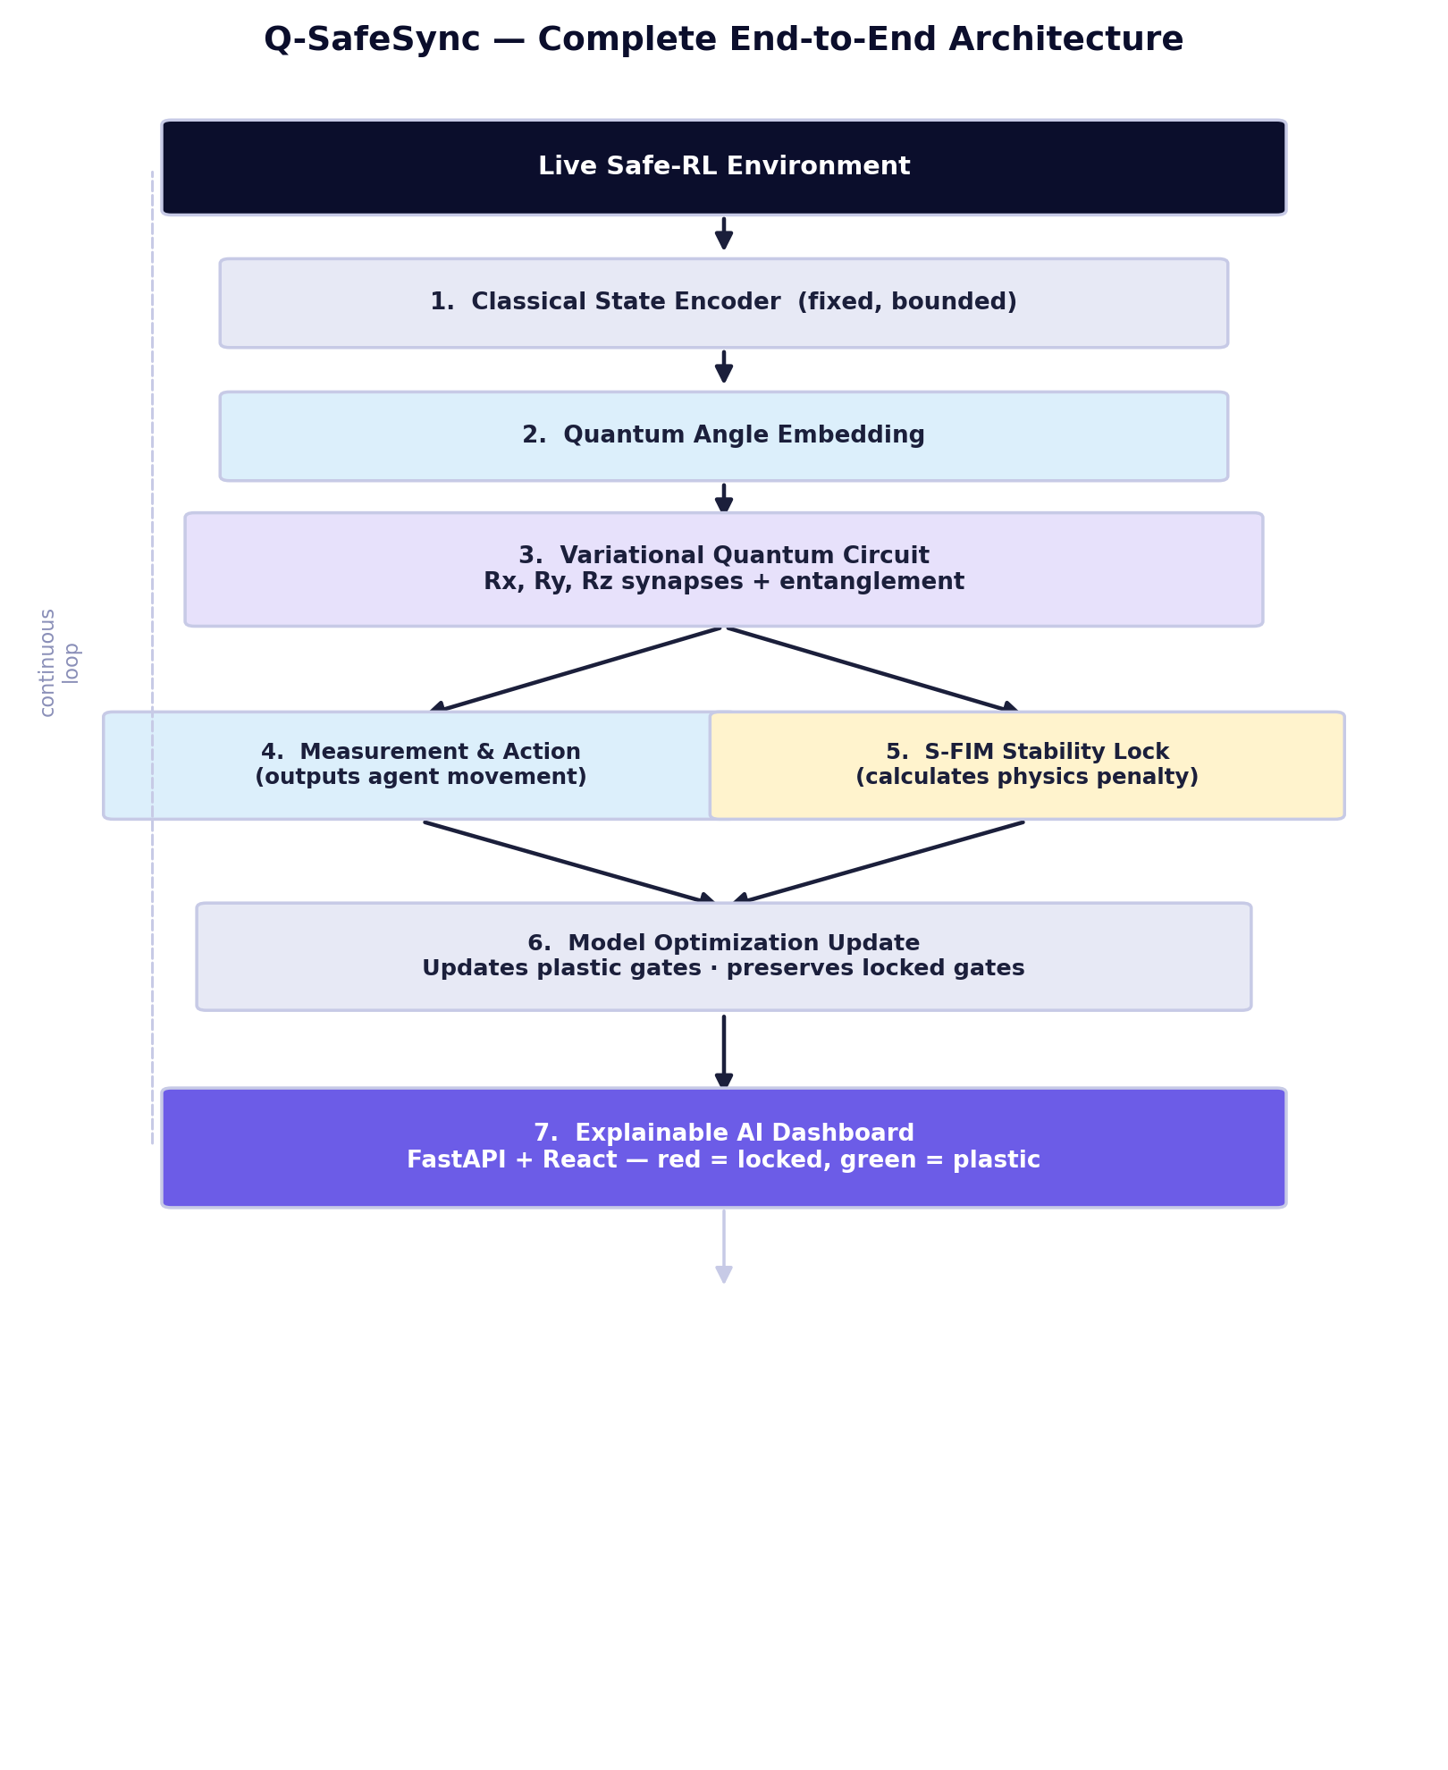

5. The Complete End-to-End Pipeline
Step | What Happens
1. Classical State Encoding | The agent receives a live observation (position, velocity, distance-to-boundary sensors) from the environment. A fixed, non-trainable normalization step compresses this into a qubit-ready feature vector — not a trainable deep network, to avoid reintroducing unbounded weights.
2. Quantum State Preparation | The feature vector is mapped onto rotation gates via Angle Embedding (PennyLane), preparing the initial quantum state.
3. The Variational Quantum Brain | The state passes through the Hardware-Efficient Ansatz (Chen & Zhang's proven design) — the plastic learning core.
4. Measurement and Action | Pauli-Z expectation values are measured and mapped to an action via a Softmax layer.
5. Safety Cost and S-FIM Calculation | In parallel, the physics engine computes the safety cost of the action taken, and the parameter-shift rule computes the Safety-Weighted Fisher Information for every gate.
6. Selective Synaptic Optimization | Gates with high S-FIM values are locked (slow learning rate); gates with low S-FIM values remain fully plastic. This step is what actually solves the stability side of the dilemma.
7. Explainable Visualization | A FastAPI backend streams live gate-level S-FIM values to a React/Vite dashboard, color-coding locked (red) versus plastic (green) gates in real time.

6. Experimental Setup

6.1 Environment
A continuous-control Safe-RL benchmark is recommended for the first working version — either a simplified custom 2D navigation task (agent position and velocity, wall boundaries as obstacles) or an existing Safety-Gym-style “Point” agent task. This keeps the state space small and the safety cost function easy to define (e.g., Euclidean distance to the nearest wall).

6.2 Qubit Count and Circuit Depth
- Simulation stage: 6–8 qubits, 4–6 ansatz layers — large enough to represent the environment's state and action space, small enough to simulate quickly on a laptop GPU.
- Hardware validation stage: a reduced 4–6 qubit version, run on IBM Quantum's free Open Plan, to confirm the S-FIM locking mechanism still functions under real NISQ noise.

6.3 Tools
- Quantum backend: PennyLane (native autodiff, parameter-shift rule, PyTorch integration).
- Classical training loop: PyTorch.
- Visualization: FastAPI backend streaming to a React/Vite dashboard.

7. Step-by-Step Recap
The whole project, in order:
1. Start from a quantum circuit already proven to never lose its ability to learn (Chen & Zhang).
2. Fix the classical front-end so it stays small and fixed, protecting that same plasticity guarantee.
3. Let the agent act in a safety-critical environment and measure a physical safety cost for each action.
4. Use the parameter-shift rule to work out which quantum gates were actually responsible for staying safe (S-FIM).
5. Lock those specific gates; leave everything else fully free to keep learning new tasks.
6. Visualize the whole process live, so the “locked vs. plastic” state of the circuit is never a black box.

